**“E-Recruit: An Online Recruitment System**

**for Insurance and Investment Agency**

**in Mindoro”**

A Thesis Project

Presented to the Faculty of the

College of Computer Studies

**MINDORO STATE UNIVERSITY**

Calapan City Campus

Masipit, Calapan City, Oriental Mindoro

In Partial Fulfillment

of the Requirements for the Course of

**IT RESEARCH METHOD**

Caibal, Lester M.

Escalera, Jandel L.

Ramos, Jef

BSIT III-F1

November 2023

**TABLE OF CONTENTS**

|  |  |  |  |
| --- | --- | --- | --- |
| **Chapter 1. Introduction** | | |  |
|  | **Project Context ……………………………………………………………………………** | | **1** |
|  | **Objectives of the Study ………………………………………………………** | | **2** |
|  | **Scope and Limitations of the Study …………………………** | | **4** |
|  | **Significance of the Study …………………………………………………** | | **4** |
|  | **Conceptual Framework ………………………………………………………………** | | **6** |
|  | **Definition of Terms …………………………………………………………………** | | **6** |
|  | | |  |
|  |  | |  |
|  |  | |  |
|  |  | |  |
|  |  |  |  |
|  |  |  |  |
|  |  |  |  |
|  |  |  |  |
|  |  |  |  |

**CHAPTER 1**

**INTRODUCTION**

In this chapter, researcher will delve into the essential aspects of the project that provide a comprehensive foundation for the project ahead.

**Project Context**

Digital technology is continuously evolving and reshaping industries. It has a huge impact on society because it influences the way people access information, communicate, and how people move in this society. In the research context, the critical aspect of conducting the research study involves soliciting information directly from the targeted users. The project context serves as a robust justification for selecting the research problem, emphasizing the researcher's capacity to address challenges. For instance, challenges in managing paper-based documents have been identified. Researchers note difficulties due to inherent risks, including the inconvenience of visiting applicants' residences to collect essential information, thereby introducing complexities to the recruitment process. An Online Recruitment System for Insurance and Investment Agency in Mindoro is crafted with the aim of addressing specific challenges identified in the local context.

The choice of this title is driven by the observed issues associated with managing paper-based documents in the recruitment process. The primary issue to address is the complexity and risk involved in handling physical documents, leading to inconveniences like visiting applicants' residences for crucial information. It is imperative to address this issue to modernize the recruitment process, enhancing efficiency and reducing potential risks and inconveniences. The choice to put in place an online recruitment system is an indication of an effort to bring modern recruitment methods in line with industry trends. This approach improves productivity while also meeting modern standards, which benefits the agency's reputation. The focus on Mindoro ensures a localized approach, tailoring the system to the unique needs and circumstances of the region. The Online Recruitment System is designed and implemented with consideration for several factors, including geographical difficulties, security issues, inefficiencies in paper-based processes, and the chance to improve stakeholder experiences. By taking a localized approach, it is ensured that the system is a focused solution that connects with the community it serves, rather than merely a generic one.

**Objectives**

The study aims to develop and design an online recruitment system for insurance and investment agents in Mindoro, that will help the employer and applicants of Mindoro to make their transactions faster and easier. The main objective of this study is to improve the overall recruitment experience and become more accurate and efficient.

Specifically, this study is intended to:

1. Implement an online platform for agent applications that accepts electronic forms and signatures.
2. Improve the agent hiring process by giving applicants easy access to online resources and support.
3. Having a more efficient way of screening and interview scheduling through online.
4. Improve the experience of the applicant by providing them a user-friendly platform when applying.
5. Make a database of potential candidates for future openings.
6. Ensure the system follows the data protection and recruitment regulations.

**Scope and Limitations of the Study**

The strategic identification of the potential and constraints inherent in the local context led to the decision to concentrate this study on developing an online recruitment system for insurance and investment agents in Mindoro, Philippines. The use of an online recruitment system is a proactive approach to modernize operations within the insurance and investment sector, which is a crucial business in the economy. The study's focus on Mindoro recognizes the significance of system customization to the local specifics, guaranteeing that the solution is not only standardized but also in line with the complexities of the regional insurance and investment landscape.

The study seeks to improve the efficiency of the hiring process by highlighting the three unique user roles: administrators, agents, and candidates. Administrators are important individuals who supervise the entire recruiting workflow since they have the authority to add or register applicants and use the system for recruitment. Agents engage with the system in a targeted way, concentrating on their unique contributions to the recruiting pipeline, thanks to the purposeful restriction of their access to the recruitment module. The system is intended to improve the applicant experience by providing applicants with the ability to not only view requirements but also submit and modify their background information via the online platform. This promotes a dynamic and user-friendly application process.

**Significance of the study**

**Insurance and investment agencies:**

The recruitment process can become more effective and economical for the agencies, which will expedite the placement of competent applicants. Consequently, this boosts the agency's overall production and makes it more competitive in the market.

**Job Seekers**

Applicants have access to an application process that is clear and easy to use. The online recruitment system enhances the whole experience by giving people a place to look at job openings, apply easily, and get timely updates on the status of their applications.

**Information Technology Experts**

IT professionals who work on the online recruitment system's creation and upkeep have hands-on experience creating and overseeing a platform that is customized to meet the unique requirements of investment and insurance companies. Their abilities are improved, and their professional development is aided by this exposure.

**Business Management Professionals**

Professionals in business management might get an understanding of the tactical benefits of using technology in hiring procedures. The report makes a case for how these technological advancements support overarching corporate objectives and improve organizational management.

**Researchers**

The E-Recruit system's developers and programmers can feel good about helping to simplify the hiring procedures for investment and insurance companies. By gaining hands-on experience in the design and implementation of specialized systems, they improve their technical proficiency and increase their marketability in the software development industry.

**Future Researchers**

This study can serve as a reference for researchers working on online recruitment platforms in the future. It provides a useful illustration of effective implementation in the insurance and investment industries, assisting future researchers in planning and carrying out comparable studies in various settings.

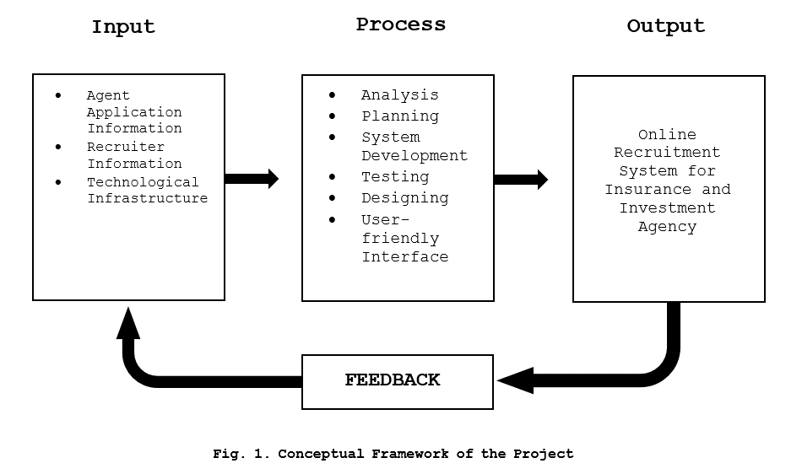**Concept of the Study**

**Figure 1. Conceptual Framework of the Project**

Figure 1, represents the relationships and sequences between these elements, showing how the input is processed through various stages to produce the desired output, which is the Online Recruitment System for the specified agency.

**Definition of Terms**

To facilitate comprehension and enhance clarity, researcher break down and explain the following terms:

**Metrics** - is a quantifiable measure used to assess and analyze the performance and effectiveness of the Online Recruitment System.

**Niche** - is the specific skill set or job market focus of the Online Recruitment System.

**Digital Technology** - is the utilization of electronic devices, software, and online resources to facilitate, and enhance various processes within the Online Recruitment System.

**Recruitment System** - is an integrated set of processes, tools, and technologies designed to manage and optimize the end-to-end recruitment and hiring process. It typically includes functionalities for posting job vacancies, collecting applications, screening candidates, and managing the overall hiring workflow.

**Overshooting** - is the situation where the number of applicants exceeds the available positions.

Toolset - is a collection of software tools and applications integrated into the Online Recruitment System to perform various tasks such as applicant tracking and evaluation.

**Social Media** - is utilized for postings, employer branding, and reaching potential applicants through platforms like Twitter, and Facebook.

**Data-Backed Hiring** - relies on the analysis of data and metrics to make informed decisions throughout the hiring process.

**Online Platform** - is a web-based interface or application that facilitates various recruitment activities, including application submission, communication between agents and applicants, and the management of the hiring workflow.

**Electronic Forms** - is a digital document that replace traditional paper-based forms in the recruitment process.

**Database** - is structured collection of data stored electronically, candidate profiles, and other relevant details.

**CHAPTER 2**

In this chapter, researcher explore existing studies to provide a solid foundation for understanding the context and significance of the current study.

**Review of Related Literatures**

This literature review examines the role of Online Recruitment Systems in the insurance and investment sector in Mindoro, Philippines. Focusing on usability, user roles, and localization, it provides insights for strategically designing a targeted recruitment solution. Sociodemographic factors, such as age, race, education, and income, are related to online job searching Karaoglu, et al. (2022) The accessibility and preferences for online job hunting differ throughout sociodemographic categories. To encourage diversity, online recruitment techniques should take these inequalities into account. According to Malki and Atlam, (2021) applying to companies in the paper form is not very effective, this statement here is one of the reasons for the development of this system. “One of the obstacles in the company recruitment process is the change of labor force generation” Prasetyaningtyas, et al. (2022), there is a lot of labor when it comes to the traditional way of recruiting people, which is why, having this kind of system, makes it easier, not just for the employer but also for the applicants. There are also a lot of hurdles when it comes to online recruitment. Some of the users may face a lot of problems and difficulties in using this kind of system The benefits of virtual recruitment seem substantial yet concerns about hurdles are valid. Moseson, et al. (2020) advancements in technology enable hospitality organizations to rely on digital recruitment efforts such as websites to attract applicants. Lee, et al. (2021) These recruitment agencies act as the middleman to connect the company to its potential applicants, and many go beyond this role to conduct remote interviews and assessments on behalf of the company. (Ho, & Henry, 2021)

Since this portal will be exclusive for the applicant that has been scouted by the employers of the company, it will be safe for outside attacks or frauds who want to take the personal information of the applicants. With the increasing popularity and convenience of online job portals, it is critical at this stage to address the fraudulent activities, which these portals are susceptible to. Ho & Henry (2021) using online recruitment methods is logistically simpler compared to offline methods, since it can be done by placing ads on websites or sending automatic messages over the internet (Blumenberg, Menezes, Gonçalves, Assunção, Wehrmeister, & Barros, 2019). That statement also adds up for the reason on developing a system that will make it easier and safer for the company when it comes to recruiting workers. Ramadhani, et al. (2019) recruitment is important for organization because it has function of collecting human resources toward the organization. Through web development, it will make recruitments a lot faster and efficient. The cost will also be lessened, because physical labors will not be needed for the most important parts in recruiting and for the application processes of the applicants. There are some companies that use this kind of method on recruiting people to work and taking advantage of the internet, Hashiyana, et al. (2021). Before using this kind of method we should have a proper grasp on using this more effectively for us not to encounter some errors when we’re at it. It is undeniably an effective method that will be innovative when it comes to recruiting people to work for companies.

**REFERENCES**

Blumenberg, C., Menezes, A. M. B., Gonçalves, H., Assunção, M. C. F., Wehrmeister, F. C., & Barros, A. J. D. (2019). How different online recruitment methods impact on recruitment rates for the web-based coortesnaweb project: A randomised trial. *BMC Medical Research Methodology*, *19*(1), 1–9. <https://doi.org/10.1186/s12874-019-0767-z>

Edirisinghe, S. M. (2020). *Recruitment Management System*. <https://dl.ucsc.cmb.ac.lk/jspui/bitstream/123456789/4486/1/2017%20MIT%20017.pdf>

Grace, M., Ventura, G., & Bringula, R. P. (2013). *Effectiveness of Online Job Recruitment System: Evidence from the University of the East*. www.IJCSI.org

Ho, D., & Henry, A. (2021). Constraints imposed on the creative cover letter writing by digital online job advertisements. *Australian Journal of Applied Linguistics*, *4*(3), 132–148. <https://doi.org/10.29140/ajal.v4n3.513>

Karaoglu, G., Hargittai, E., & Nguyen, M. H. (2022). Inequality in online job searching in the age of social media. *Information Communication and Society*, *25*(12), 1826–1844. <https://doi.org/10.1080/1369118X.2021.1897150>

Kmail, A. B., Maree, M., Belkhatir, M., & Alhashmi, S. M. (2016). An automatic online recruitment system based on exploiting multiple semantic resources and concept-relatedness measures. *Proceedings - International Conference on Tools with Artificial Intelligence, ICTAI*, *2016*-*January*, 620–627. <https://doi.org/10.1109/ICTAI.2015.95>

Lee, L., Guzzo, R. F., Madera, J. M., & Guchait, P. (2021). Examining Applicant Online Recruitment: The Use of Fictitious Websites in Experimental Studies. *Cornell Hospitality Quarterly*, *62*(1), 76–88. <https://doi.org/10.1177/1938965520965223>

Malki, Z., Atlam, E., Malki, Z., & Atlam, E. (2021). Graduate Students and Companies Web Based E-Recruitment System. *Journal of Computer and Communications*, *9*(9), 71–84. https://doi.org/10.4236/JCC.2021.99005

Moseson, H., Kumar, S., & Juusola, J. L. (2020). Comparison of study samples recruited with virtual versus traditional recruitment methods. *Contemporary Clinical Trials Communications*, *19*, 100590. <https://doi.org/10.1016/j.conctc.2020.100590>

Obipi , I. O., & Kalio, N. (2018). Recruitment Management System and Employee Procurement in the Oil and Gas Sector in Nigeria. *International Journal of Human Resource Management and Research*, *8*(2), 7–18. https://doi.org/10.24247/ijhrmrapr20182

Prasetyaningtyas, S. W., Sim, M., Triantoro, B. H., & Allen, A. (2022). THE USE OF EMPLOYER BRANDING DIMENSIONS TO ATTRACT FRESH GRADUATES. *Jurnal Bisnis Dan Manajemen*, *23*(1), 3–15. <https://doi.org/10.24198/JBM.V23I1.891>

Ramadhani, F., & Zarlis, M. (n.d.). *Analysis of e-Recruitment System Design*. https://doi.org/10.17706/ijeeee.2019.9.1.38-45

Rosoiu, O., & Popescu, C. (n.d.). *E-recruiting Platforms: Features that Influence the Efficiency of Online Recruitment Systems*. https://doi.org/10.12948/issn14531305/20.2.2016.05

Samoli, C. (2021, May 20). *How management systems drive value in business operations*. Monday.com Blog. https://monday.com/blog/project-management/management-systems/

Sehgal, V. K., Jagtiani, A., Shah, M., Sharma, A., Jaiswal, A., & Mehta, D. (2014). Job portal-A web application for geographically distributed multiple clients. *Proceedings - 1st International Conference on Artificial Intelligence, Modelling and Simulation, AIMS 2013*, 199–204. https://doi.org/10.1109/AIMS.2013.38

|  |
| --- |
| **Checked and Reviewed by:** |
|  |
| **Mr. Christian I. Cabrera** |
| **ITC311 - Facilitator** |